Tribo-Dynamics of Bearings for Electric and Hybrid Electric Vehicles’ Powertrains

Literature Review

# Introduction

## Rolling Element Bearings

Rolling element bearings encompass both ball and roller bearings. They are one of the most widely used components in machinery; with uses extending from miniature electric motors up to turbofan engines in planes or wind turbines. These bearings are made up of 3 main components, the races, rollers and cage. The inner and outer races house the rolling elements, which rotate around the races and are angularly separated by the cage. These bearings have two primary purposes: to transmit load from other connected elements (typically rotating shafts) and to convert relative sliding motion into rolling motion to reduce rotational friction in the system.

Roller bearings in automotive transmissions are used to support the rotation of the shaft and the radial and axial forces applied during gear meshing. Common bearings include cylindrical roller bearings (CRB) that support high radial loads and high-speed operation, as well as taper roller bearings (TRB) for high radial and axial loads. Single or two stage gearing in electric transmissions mean that bearings in both the electric motors and input shaft to the gearboxes operate under high speeds, in excess of 32,000rpm.

# Elastohydrodynamic Lubrication

The rollers within a bearing carry an instantaneous share of the overall load applied to the bearing. Deviation of the supported shaft centre from its nominal geometric centre results in a loaded region of the bearing. In the conjunction between the bearing roller and race, the non-conformal nature of the contact generates very high pressures and local surface deformation occurs. This local elastic deformation as well as the increase of lubricant viscosity at high pressures enhances hydrodynamic film formation. This method of fluid-film lubrication is known as elastohydrodynamic lubrication (EHL) [3]. This problem combines classical Hertzian contact mechanics with hydrodynamic lubrication theory.

## Hertzian Contact Mechanics

Two types of contacts occur in machine elements: conformal and non-conformal. Conformal contacts occur between a concave and a convex body of similar radius, such as in journal bearings. This leads to a relatively large contact area over which load can be distributed and resultant pressures are in the order of MPa. The contact between rolling elements and races is non-conformal in nature as the contacting surfaces are both convex. This type of contact creates a very small contact region over which force is transmitted, leading to very high contact pressures being generated in the order of GPa. Under these pressures, the contact surfaces deform elastically. In the case of a lubricated contact, a lubricant film forms in between the contacting surfaces in the order of microns (typically <2µm [4]. Non-conformal contacts are typically found in rolling element bearings, gear contacts and cam follower pairs.

A fundamental aspect of these contacts is that the approach of the bodies under external load leads to the deformation of both bodies and the emergence of a contact patch. For the case of two contacting spheres of the same radius, a circular contact emerges of radius 2a. For two cylinders in contact with their axis parallel, a rectangular or line contact is formed along the length of the cylinders with width 2b. Both cases are shown in Figure 2. The third contact geometry is an elliptical point contact which results from contacting bodies that have different radii along both principal axes [5]. In the case of a cylindrical or tapered roller bearings such as those found in electric motors and transmissions, the mutual approach of the roller and race forms a line contact.

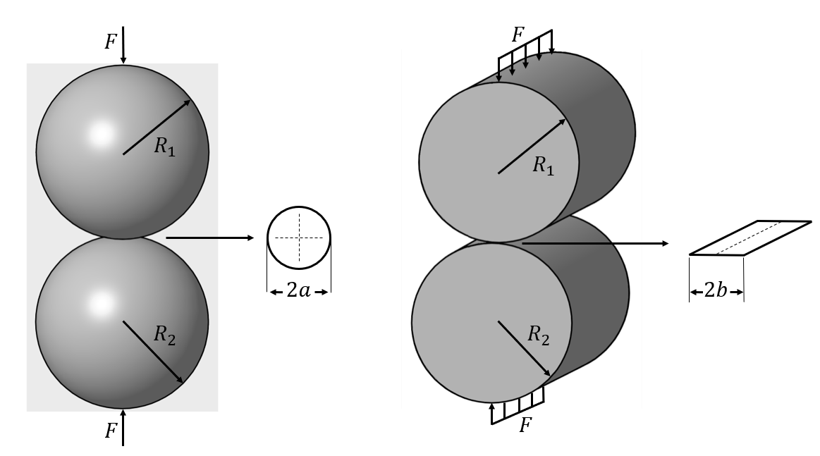

Figure - Hertzian contact patch: point contact (left), line contact (right)

The spheres of cylinders depicted in Figure 2 with radii and can be simplified as a rigid cylinder in contact with an elastic half-space. The radius of this curved surface is known as the reduced radius, :

|  |  |
| --- | --- |
|  | [1] |

The material properties of the two bodies a treated in a similar way. The elastic modulus, , and Poisson’s ratio, , of both bodies are combined to for the reduced elastic modulus:

|  |  |
| --- | --- |
|  | [2] |

According to Hertz’s theory of elastostatic solids in contact [6] and assuming the contact is frictionless, when load is applied to the cylinder it will experience very small strains. The amount that the cylinder deflects is much smaller than the radius of the cylinder, that is . The total area of the contact is also much smaller than the radius of the cylinder (exaggerated in Figure 3). For example, a cylinder with a radius in order of mm will have a contact width of a few tenths of a mm and deflection a few tenths of a micron ().

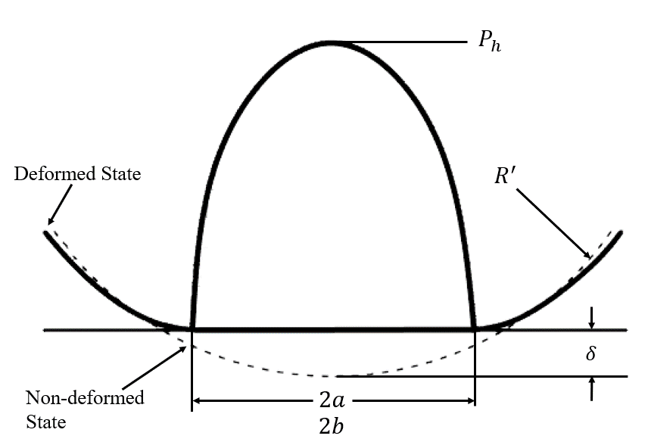

Figure - Hertzian contact deflection

The value of the deflection determines the stiffness of the contact and the gap that is available for a lubricant film to form. The contact width determines the contact pressures and hence maximum sub-surface stresses which could lead to inelastic deformation and subsequent fatigue spalling.

Analytical formulae provide a way of calculating the dimensions of the contact patch, , and the resultant maximum Hertzian pressure, given a known force, , material properties and geometry of bodies. For the case of the line contact these are:

|  |  |
| --- | --- |
|  | [3] |

|  |  |
| --- | --- |
|  | [4] |

where is load per unit length.

## Elastohydrodynamic Lubrication Background

### History

Under the EHL regime, both the elastic deformation of the solids in contacts as well as hydrodynamic theory are considered. Elastic bodies in contact for the case of ellipsoidal contacts was first investigated by Hertz in 1881 [6], allowing him to obtain the pressure distribution within an ellipsoidal contact. Separate studies on hydrodynamic lubrication were being performed by Reynolds in 1886 [7], based on a simplified version of the Navier-Stokes equation. It took a further 30 years before the two studies would be combined.

Early EHL studies began in 1916 when the pioneering work by Reynolds was applied to a simplified model of a gear-tooth contact by Martin [8]; replicated as two contacting cylinders. This analysis assumed that the solid bodies were rigid and the lubricant to behave with constant viscosity (ie. a hydrodynamic analysis). The resultant pressures were too high and the film thickness so low (1-10nm) that coverage of asperities (typical order of 100nm for machined gear teeth) was not possible. This contradicted experimental findings where machining tracks on high-speed gear tooth flanks were still visible after prolonged usage, which could only be explained by the presence of a sufficient lubricant film.

Between the 1930’s and 1950’s, significant research was performed to include both the elastic deformation of the surfaces and the effect of pressure on viscosity. Peppler [9] and Meldahl [10] both included the effects of surface deformation for non-conformal contacts, with Gatcombe [11] amongst others investigating viscosity increase due to the high pressure in the contact area. Typical EHL pressures are in the range of 0.5-4GPa and the resulting piezo-viscous properties were found to be partially instrumental to forming the film.

Considered the origin of EHL, Grubin’s pioneering work in 1949 [12] combined both elastic deformation and viscosity increase under pressure in film thickness calculations for the first time. In this analysis, he assumed that the deformed surface profiles in a highly loaded lubricated contact matched those produced in a classic dry Hertzian contact of the same materials and loading conditions. Reynolds equation could then be solved at the inlet region of the contact and a more accurate determination of the separation of the solids in the central region was found. This led to a film thickness in the predicted range (an order higher than Martin’s theory) and a more realistic pressure distribution than previous work. This pioneering study formed the basis for future EHL studies.

The first numerical solution of the line contact problem was presented shortly after by Petrusevich [13] which agreed with Grubin’s main conclusions. It contained the three main features of an EHL contact: a nearly parallel film in the contact zone with local constriction at the exit, a Hertzian pressure profile, and secondary local maximum pressure or ‘spike’ at the outlet (see Figure 6). In 1959, Dowson and Higginson [14] presented their numerical solution to the isothermal line contact EHL problem. Their iterative inverse method enabled the evaluation of film thickness and pressure distribution for line contact problems for lightly loaded cases. Throughout the 1960s, the authors investigated the effects of variables such as dimensionless surface velocity, materials parameter and load on EHL solutions. The authors then curve fitted their results and generated an empirical formula for isothermal line contacts [15], which was then improved upon by Dowson [16] and Dowson and Toyoda [17]. The formulae predict the minimum film thickness as a function of the rolling velocity, load and material parameters.

Empirical formulae are widely used today for analytical calculations that do not require the computational intensity of a full numerical solution. They are, however, somewhat limited to the operating parameters used in original simulations and do not offer the capabilities of a full numerical solution such as the modelling of inlet starvation at high speeds.

### Numerical Methods

There are 2 main numerical methods for solving the elastohydrodynamic problem, direct and inverse. Typically, Reynolds equations is solved for pressure based on the lubricant film thickness. Early studies using this direct method suffered from convergence in highly loaded cases.

#### Inverse Method

Ertel [18] introduced the inverse method for the hydrodynamic problem, which was adopted by Dowson and Higginson [14] for the EHL line contact problem. Here, the film thickness profile is found from a given pressure distribution. Solving the elastic deformation equation provides a second film thickness profile that corresponds to the same pressure distribution. This pressure distribution is then modified manually until the film thickness solutions converge.

This approach has many disadvantages. For low load cases with a non-parallel film shape in the contact region, this method is not suitable since the deviation of the Hertzian starting solution is too large. The film thickness equation is also insensitive to local variations in pressure. Finally, it is only suitable for line contact 1-dimensional cases since the Reynolds equation cannot be integrated for the two-dimensional case. Evans and Snidle [19] overcame the 2-dimensional limitation by using their quasi-static solution where a direct method was applied at the inlet zone and the inverse method in the contact zone. The aim was to overcome the instabilities of the forward iterative method to solve heavily loaded contacts which were limited to 0.5GPa, whereas common stresses in practice are typically in the order of 1.5GPa, reaching as high as 4GPa in some cases. A solution was only found for heavily loaded cases and the approach was limited by the need for an accurate initial estimate for pressure.

#### Direct Method

The direct iterative method is the most common method whereby Reynolds equation is solved to find the pressure with a given film thickness. This pressure distribution is used with the elastic equation to calculate a new film shape. The pressure distribution must also achieve equilibrium with the externally applied load.

Two different direct methods have been used to solve the discretized Reynolds equation. The first is the iterative technique which has been applied to the 1-dimensional line contact problem [20] as well as the two-dimensional point [21] and elliptical [22] contact problem. The Gauss-seidel scheme was used, solving Reynolds equation for pressure based on film thickness and iterating between the two until convergence was met. Force equilibrium in an outer loop was calculated by integrating pressure across the contact domain and ensuring convergence between the resultant force and the applied external load. The solution comprises of 3 nested loops that must all converge. Underrelaxation between successive iteration is applied to aid convergence, however this iterative method does not converge for high loads. Furthermore, the number of iterations to achieve convergence is large (ie. of the square of the number of computational points used) and thus excessive computation times result.

The second solution method is the Newton-Raphson method. This was first applied by Okumara [23] and later by Houpert and Hamrock [24], where pressures as high as 4.8GPa were obtained with low CPU times. These low CPU times are a significant advantage of the NR methodology, with a smaller number of iterations resulting in much faster convergence than Gauss-Seidel.

Further numerical development came in the form of the multi-level method, first used by Lubrecht et al. in 1986 [25]. Venner et al. [26] used a multilevel multi-integration for point and line contacts in 1990 to reduce the computational cost of solving the film thickness integral. This allowed more nodes in the computational domain to be used for more complex problems with again much faster solution times. Finer grids could therefore be used, yielding faster results than NR for more complex cases with a solution time proportional to (n log n), with n being the total number of nodes in the computational domain. This work was mainly focussed on reducing computational time for the point contact problem, with the authors acknowledging the applicability of the Newton-Raphson numerical scheme for the line contact problem.

### Starvation

The assumption of a fully flooded inlet region to the contact is not always valid. Starvation may occur if insufficient lubricant is entrained into the contact; significantly affecting EHL characteristics such as film formation and friction coefficient. This starvation is found to be greater at higher speeds, with higher viscosity lubricants and limited lubricant supply [27]. At high speeds, lubricant replenishment is diminished. For a fully flooded contact, the pressure builds upstream of the contact starting from a pressure gradient close to zero. With insufficient lubricant, the contacting bodies entrain two layers of lubricant, which then merge and form a meniscus at the contact inlet; causing the pressure rise to occur closer to the contact centre with a non-zero pressure gradient and reduced shape of the characteristic pressure distribution [28].

Analytical work on this topic began for the line contact problem by Wolveridge et al. [29] and later developed for the elliptical contact problem by Hamrock and Dowson [30]. In these studies, the inlet distance to the centre of the contact domain is varied as an input parameter. As the inlet distance is extended, the flooded condition at the entrance to the contact becomes greater. At a certain inlet distance, the film thickness in the contact is hardly affected (see Figure 4), and this is defined as the threshold between starvation and a fully flooded inlet condition. For the case of shorter inlet distances and subsequent starved condition, an equation was presented that could adjust the starved film thickness based on the starvation level and flooded film thickness.

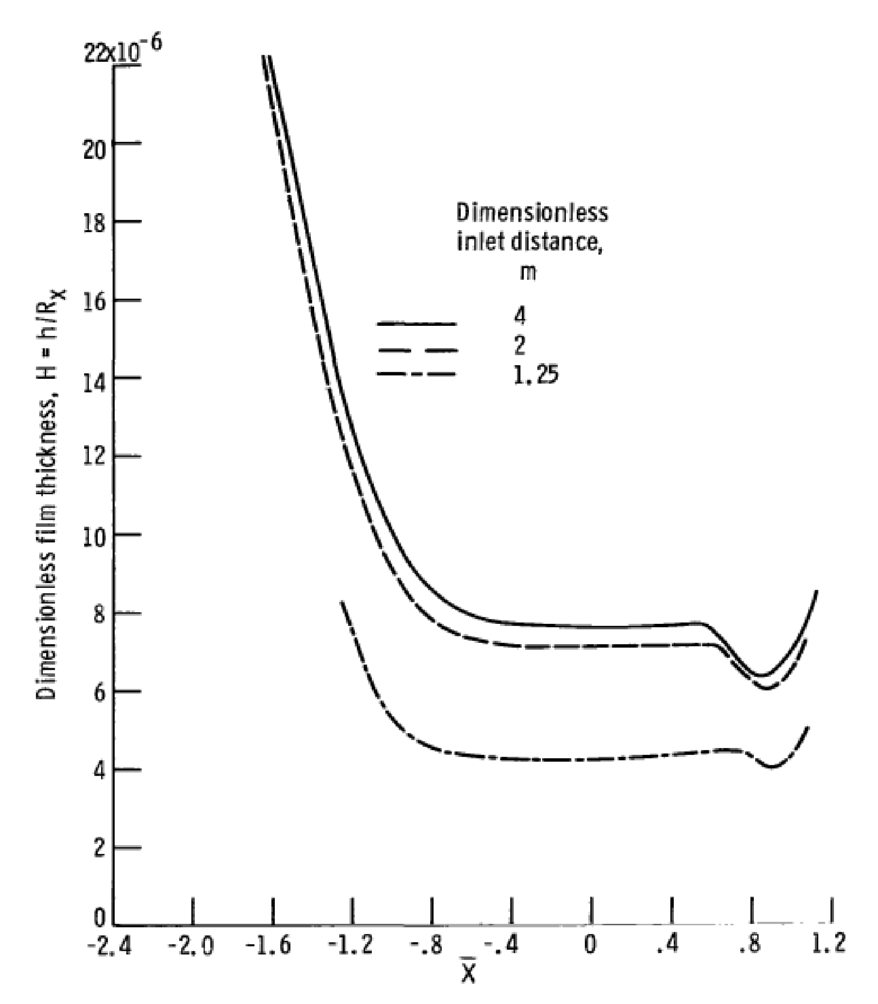

Figure - Effect of dimensionless inlet distance on film thickness for starvation modelling [30]

### Thermal EHL

Heat is generated in an EHL contact in two ways: due to the viscous shearing of the lubricant and the compressive action of the generated pressures [31]. Classic EHL theory is isothermal and considers a Newtonian fluid with no temperature rise from sliding at the conjunction. For the case of pure rolling, this is sufficient to predict film thickness and inlet temperature rise. Rolling element bearings, however, undergo complex rolling and sliding motions depending on the nature of the loading and contact conditions. The presence of sliding requires a rheological model that considers the viscosity relationship with pressure as well as the use of the energy equation to calculate temperature rise within the lubricant film.

The three-dimensional energy equation has been solved by various authors for the line contact [32], point contact [33], [34] and finite line contact [35]. The generated heat is carried along the direction of entraining motion, in the direction of side leakage from the contact, and through the bounding surfaces of the contact. This can be reduced to fewer dimensions for the assumption of negligible heat transfer to the contacting bodies in the direction of the film thickness.

It has been found in the case of the point contact under low loads, thermal effects on pressure distribution and film thickness are negligible [36]. However, Kim and Sadeghi [33] concluded that with higher loads, the temperature rise in the film is significant. Under pure rolling conditions, the lubricant film temperature rise was only a moderate 15 °C above ambient and occurred at the inlet zone. As the slide/roll ratio was increased to 0.2, for the same load and speed conditions a temperature rise of 140 °C above ambient resulted at the contact centre, with the dominant mode of heat transfer being shear heating in the contact. The authors also adjusted the ellipticity parameter of the contact [34], with higher ellipticity parameters bringing the elliptical shape of the contact closer to that of a line. In this study, the load was more moderate, and the temperature rise for pure rolling and a slide/roll ratio of 0.2 was 4.5 °C and 16 °C respectively.

Habchi et al. [37] found that even under light loads and moderate speed conditions, thermal effects were still noticeable for Newtonian fluids. For lightly loaded cases, thermal and isothermal results were comparable up to entrainment velocities of 1 m/s but began to diverge slightly above this: in line with experimental findings. Additionally, as the slide/roll ratio is increased above 0.5, both central and minimum films are found to decrease for the thermal model, whereas the isothermal model remains constant. This is due to shear heating reducing lubricant viscosity. The difference was found to be only 0.015 µm between pure rolling and close to pure sliding for a lightly loaded contact.

Shear thinning of the lubricant also occurs at the inlet region to the contact. EHL films are micron level thickness, and assuming a fully flooded inlet, not all of the lubricant will traverse into the contact. Rejected lubricant will then produces some reverse flows which will shear the lubricant, increasing the inlet temperature and hence viscosity of the fluid [38].

It is therefore clear that the thermal elastohydrodynamic model is necessary for highly loaded conditions with modest slide/roll ratios.

## Lubrication Regimes

Lubricated contacts fall into 4 main regimes, these are:

* Hydrodynamic: Contacting surfaces are completely separated by the lubricant film. Load is light, typically several Newtons. The contact surfaces do not experience deformation and resultant pressures are in the region of MPa.
* Elastohydrodynamic: Contacting surfaces are completely separated by lubricant film; however, load is medium to heavy. Contact deformation occurs and resultant contact pressures are in the region of GPa.
* Mixed: An interrupted oil film separates the two surfaces, ie. some asperity interaction occurs. Mixed lubrication can occur under any load and is dependent on the film thickness and asperity height.
* Boundary: The lubricant film is negligible, and surfaces directly interact. This a dry contact. At medium and high loads, Hertzian contact conditions can be assumed.

The loaded contact region of bearings are typically in the elastohydrodynamic regime of lubrication. The film thickness to asperity roughness height (lambda ratio) is large enough that the surface features do not typically influence the lubricant thickness and often a smooth surface is assumed. Under operation, emerging clearances result in unloaded regions of the bearing which can cause the roller-to-race contact to deviate from the elastohydrodynamic lubrication regime towards hydrodynamic regime, resulting in sliding and roller-cage collisions [31]. Hence, the contact may go through different regimes of lubrication throughout its rotation.

Film thickness and surface roughness are related by Stribeck [39] using the specific film thickness:

|  |  |
| --- | --- |
|  | [5] |

where is the lubricant film thickness and is the roughness height of the asperities on the contact surfaces. Figure 5 presents the various lubrication regimes and their associated coefficient of friction. For rougher surfaces, mixed-EHL occurs where contact of surface asperities occurs, increasing friction. The coefficient of friction then reduces as the film increases or asperity height reduces, until the hydrodynamic regime is reached, and the thicker films increase viscous friction.

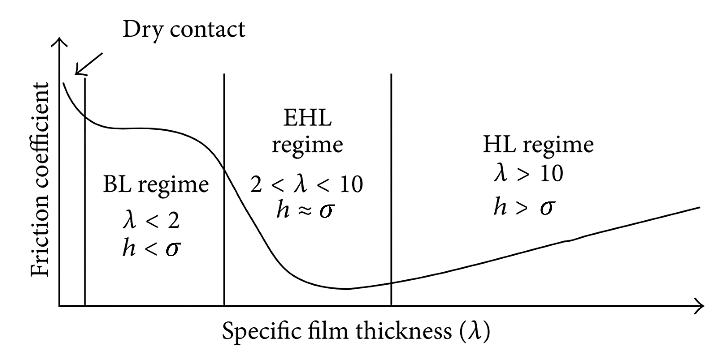

Figure - Stribeck curve and specific film thickness () [40]

## Elastohydrodynamic Pressure and Film Characteristics

If there is relative velocity between two contacting surfaces, a thin film is formed due to the wedge mechanism and lubricant is entrained into the contact. The pressure profile across the contact deviates from the dry Hertzian parabolic distribution due to the presence of the lubricant.

Figure 6 shows the deviation of the film pressure from the dry Hertzian pressure. The main deviation occurs at the outlet of the contact due to the exit conditions. At the entry of the contact, the increasing pressure profile acts to oppose the flow of lubricant into the contact due to the entraining motion. At the outlet, the Couette profile and the pressure differential acts in the same direction to force lubricant out of the contact. For mass flow rate of the lubricant across the contact to be conserved, an outlet constriction is formed to reduce the flow area. The pressure spike at the outlet generates this deformation of the surfaces to maintain this flow balance and is a result of the piezo-viscosity of the lubricant. The two laws that must be obeyed are therefore the force equilibrium (the differential of pressure across the contact must equal the applied force), and the flow continuity.

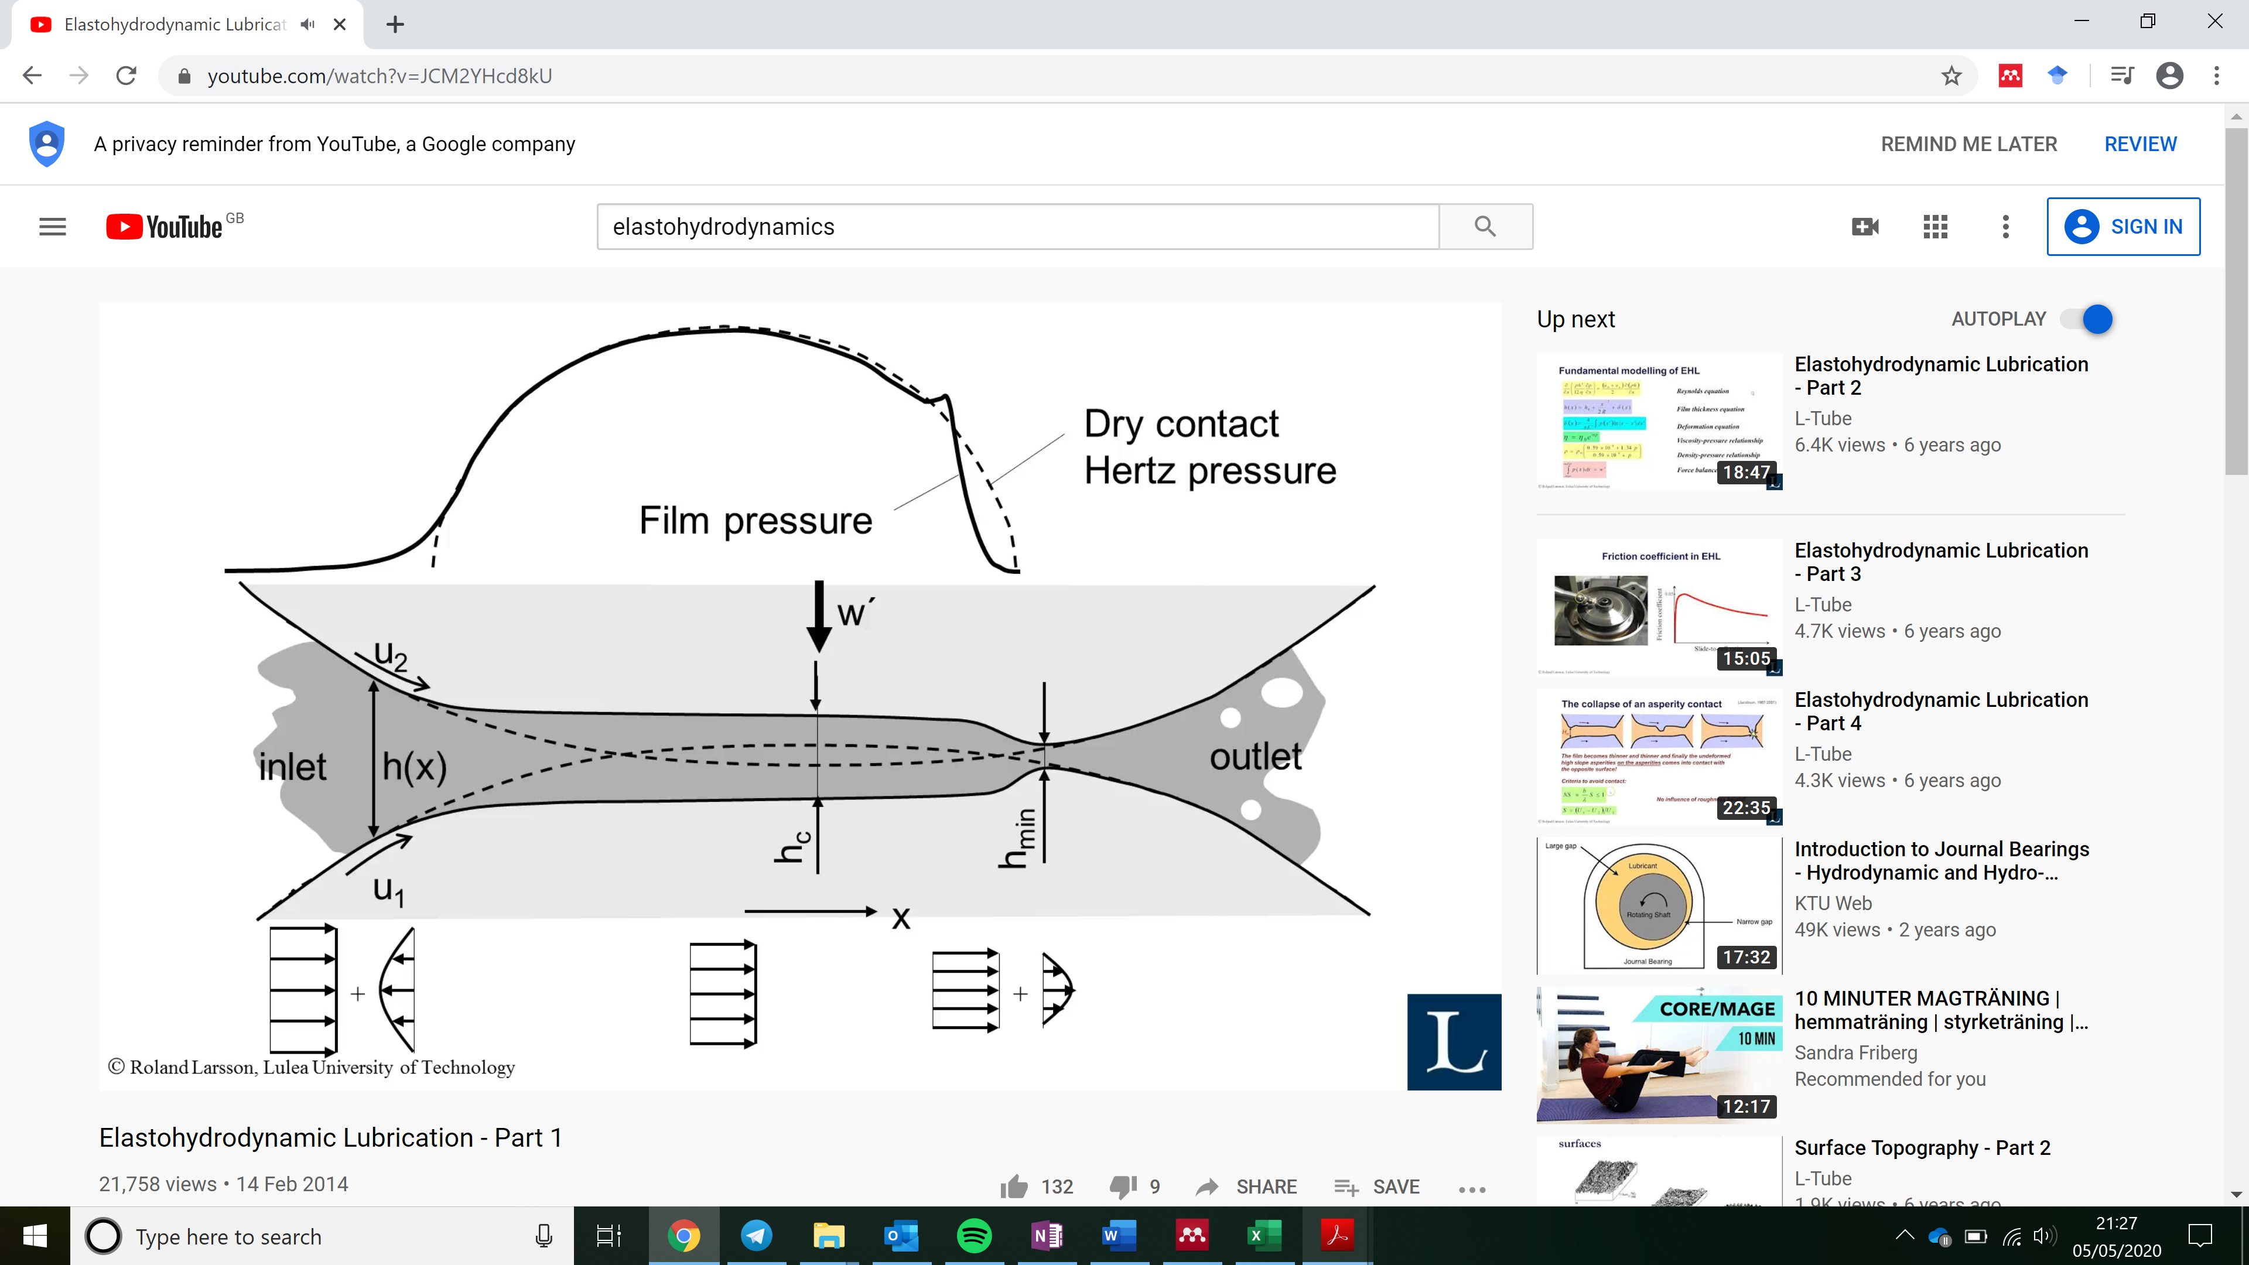

Figure - EHL film and pressure distribution [41]

# Numerical EHL Model and Solution

## Reynold’s Equation

Reynold’s equation [7] is the governing equation of fluid film lubrication theory. For Newtonian fluids it can be derived from the full Navier-Stokes equations making the following assumptions, primarily the neglection of inertial forces and only retaining viscous forces on the lubricant [3]:

1. Body forces are negligible (mass of film is negligible)
2. Pressure is constant through the lubricant film (z-direction) due to thin film (dimensions of the region of pressure are typically 100 times the central film thickness).
3. No slip at boundaries
4. Lubricant flow is laminar (low Reynolds number)
5. Inertia and surface tension forces are negligible compared with viscous forces (working fluid has low mass and low acceleration)
6. Shear stress and velocity gradients are only significant across the lubricant film (z-direction)
7. The lubricant behaves as a Newtonian fluid
8. Lubricant viscosity is constant across the film (z-direction)
9. The lubricant boundary surfaces are parallel or at a small angle with respect to each other

Reynolds equation is a second order, non-linear partial differential equation. It is made up of the pressure induced terms (Poiseuille flow) and the boundary velocity-induced term (Couette flow).

For the line contact problem, such as that at the conjunction between a cylindrical roller and race, dimensions in the side-leakage direction, , are much bigger than the direction of entraining motion, . Pressure in direction is assumed constant due to the negligible gradient, and the contact can be analysed in 1-dimension. The assumption is valid in the contact apart from small regions near the edge where the roller profile changes. A simplified 1-dimensional version of Reynolds equation can therefore be used:

|  |  |
| --- | --- |
|  | [6] |

To solve Reynolds equation numerically, it must first be discretized and then solved using the finite-difference method. The following procedure explains this discretization

Removing the transient squeeze term and replacing terms for simplification:

|  |  |
| --- | --- |
|  | [7] |

Due to the many orders of magnitude differences between lubricant film thickness (µm) and pressures (GPa), the numerical solution often becomes unstable. Dimensionless parameters are therefore defined to remove this instability. These are as follows:

|  |  |
| --- | --- |
|  |  |
|  |  |
|  |  |
|  |  |
|  |  |
|  |  |
|  |  |

Terms in the simplified Reynolds equation are replaced with dimensionless parameters. Similar terms are then grouped and rearranged to give the final form:

|  |  |
| --- | --- |
|  | [8] |

where

|  |  |
| --- | --- |
|  | [9] |

Grouping terms for simplicity:

|  |  |
| --- | --- |
|  | [10] |

|  |  |
| --- | --- |
|  | [11] |

Making substitutions

|  |  |
| --- | --- |
|  | [12] |

|  |  |
| --- | --- |
|  | [13] |

The final term is removed as velocity, , is independent of when no stretching of the surfaces occurs. This is then differentiated to give:

|  |  |
| --- | --- |
|  | [14] |

and

|  |  |
| --- | --- |
|  | [15] |

Substituting into equation 13:

|  |  |
| --- | --- |
|  | [16] |

|  |  |
| --- | --- |
|  | [17] |

The final form is therefore:

|  |  |
| --- | --- |
|  | [18] |

## Finite Difference Formulation

For finite difference formulation, the central difference formula based on Taylor series expansion [42] is used. The second derivative of pressure using second order central discretization for the spatial domain is therefore:

|  |  |
| --- | --- |
|  | [19] |

and the first derivative is given by:

|  |  |
| --- | --- |
|  | [20] |

Replacing terms in the final form of discretized Reynold equation:

|  |  |
| --- | --- |
|  | [21] |

|  |  |
| --- | --- |
|  | [22] |

Pressure at each node point can then be represented by:

|  |  |
| --- | --- |
|  | [23] |

Simplified to

|  |  |
| --- | --- |
|  | [24] |

where,

|  |  |
| --- | --- |
|  | [26] |

|  |  |
| --- | --- |
|  | [27] |

|  |  |
| --- | --- |
|  | [28] |

## Effect of pressure on lubricant viscosity

EHL temperatures are typically in the region of 0.5-4 GPa. The resultant behaviour of the viscosity at these pressures is instrumental in forming the EHL film and must be accounted for. The Barus law [43] determines viscosity increase with pressure assuming constant ambient temperature:

|  |  |
| --- | --- |
|  | [29] |

where is the lubricant viscosity at gauge pressure, **,**  is the viscosity at = 0, and is the pressure-viscosity coefficient (m2/N) and is specific to the lubricant. This relationship does not account for the change in with temperature and pressure [4], becoming inaccurate above 0.5 GPa.

A more comprehensive relationship which simultaneously includes the effects of temperature and pressure was one proposed by Roelands [44] and developed by Houpert [45]. Roeland’s law is therefore accurate at higher contact pressures:

|  |  |
| --- | --- |
|  | [30] |

The Roelands pressure-viscosity coefficient, , is a function of both and , with being the reference or ambient temperature, for example at the inlet:

|  |  |
| --- | --- |
|  | [31] |

where

|  |  |
| --- | --- |
|  | [32] |

and

|  |  |
| --- | --- |
|  | [33] |

The oil constants and are independent of both pressure and temperature, and can be typically taken as 0.68 for computational purposes.

## Effect of pressure on lubricant density

For accurate film EHL film shape calculations, the effect that pressure has on the lubricant density must be considered. The most common equation for this is the widely used Dowson and Higginson model [46]:

|  |  |
| --- | --- |
|  | [34] |

where is the lubricant atmospheric pressure. This has also been modified to account for temperature effects:

|  |  |
| --- | --- |
|  | [35] |

## Effect of temperature on viscosity

Most EHL work assumes constant temperature of the contact and that viscosity and density are dependent on pressure only. Standard experiments have been performed to assess effect of temperature on viscosity. Results have previously been curve fit by Crouch and Cameron [47], with the most simple fit due to Reynolds:

|  |  |
| --- | --- |
|  | [36] |

where is the viscosity of the lubricant at temperature , is the viscosity at representative temperature , and represents the temperature difference between the two. is the thermoviscous constant and is lubricant specific. This relationship is only valid for small temperature rises of the lubricant. A more accurate and widely used equation is the expression from Vogel:

|  |  |
| --- | --- |
|  | [37] |

with the three constants dependant on the lubricant, obtained from knowing three pairs of values for and .

## 1D EHL Solution Methodology

Reynolds equation is used to calculate contact pressures. Assuming a thin film of Newtonian lubricant in a line contact, following form is used and discretized in the manner shown previously:

|  |  |
| --- | --- |
|  | [38] |

where is the direction of entraining motion into the contact. Squeeze film motion is neglected for this analysis. For the pressure-density relationship in the compressible model, Dowson-Higginson model [46] is used

|  |  |
| --- | --- |
|  | [39] |

The increase in lubricant viscosity with pressure is modelled using Roeland’s law [44] due to its accuracy at higher contact EHL pressures

|  |  |
| --- | --- |
|  | [40] |

where

|  |  |
| --- | --- |
|  | [41] |

Pressure distribution is obtained from the variations in film thickness at the contact, which is defined as below:

|  |  |
| --- | --- |
|  | [42] |

where is the central film thickness, the second term represents an idealised film thickness parabola, with the ultimate term representing the localised contact deflection. Central film thickness is first estimated using:

|  |  |
| --- | --- |
|  | [43] |

The dimensionless materials, speed and load parameters used are:

|  |  |
| --- | --- |
|  | [44] |

Below, the method of solution for the numerical EHL model is provided:

1. The load value at the roller-race contact is input, this is often obtained from a dynamic model.
2. An initial estimation of lubricant film thickness, is made.
3. Inlet and outlet distances are set to -4.5 to 1.5 based on the contact half width calculation. This sets up the computational domain.
4. Pressure distribution and film thickness are obtained through simultaneous solutions of equations 38-42. Newton-Raphson iterative scheme is used for speed and robustness of convergence [23]. Pressure convergence criterion is required for the iterative solution:

|  |  |
| --- | --- |
|  | [45] |

where

Under-relaxation is applied between successive iterations where the criterion is not met

|  |  |
| --- | --- |
|  | [46] |

where the under-relaxation factor is typically .

1. Hydrodynamic reaction load is calculated using the integration of pressure over the computational domain

|  |  |
| --- | --- |
|  | [47] |

The total reaction from the hydrodynamic load should equal the total load share on the roller, , obtained from the explicit tribological model. Convergence criterion is applied

|  |  |
| --- | --- |
|  | [48] |

where

## Numerical EHL Validation

Conjunction level validation of the numerical method for solving the EHL film thickness and pressure distribution was performed using the work of Masjedi and Khonsari [48]. These were validated against his smooth surface plots with no asperity pressure contribution. The dimensionless input parameters were = 1 x 10-4, = 1 x 10-11 and = 4500. The results shown in Figure 7 and Figure 8 show very good agreement between the model used in the study and the work of Masjedi and Khonsari.

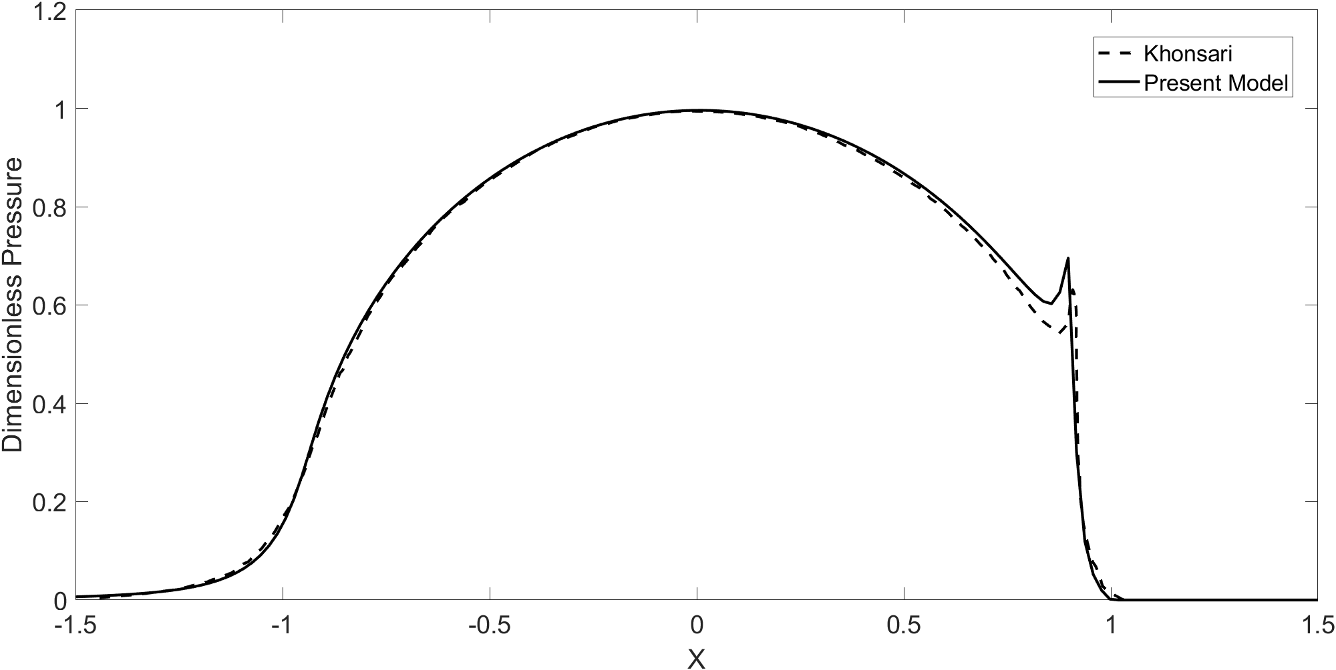

Figure - Validation of pressure distribution, present model (solid), Masjedi and Khonsari (dash)

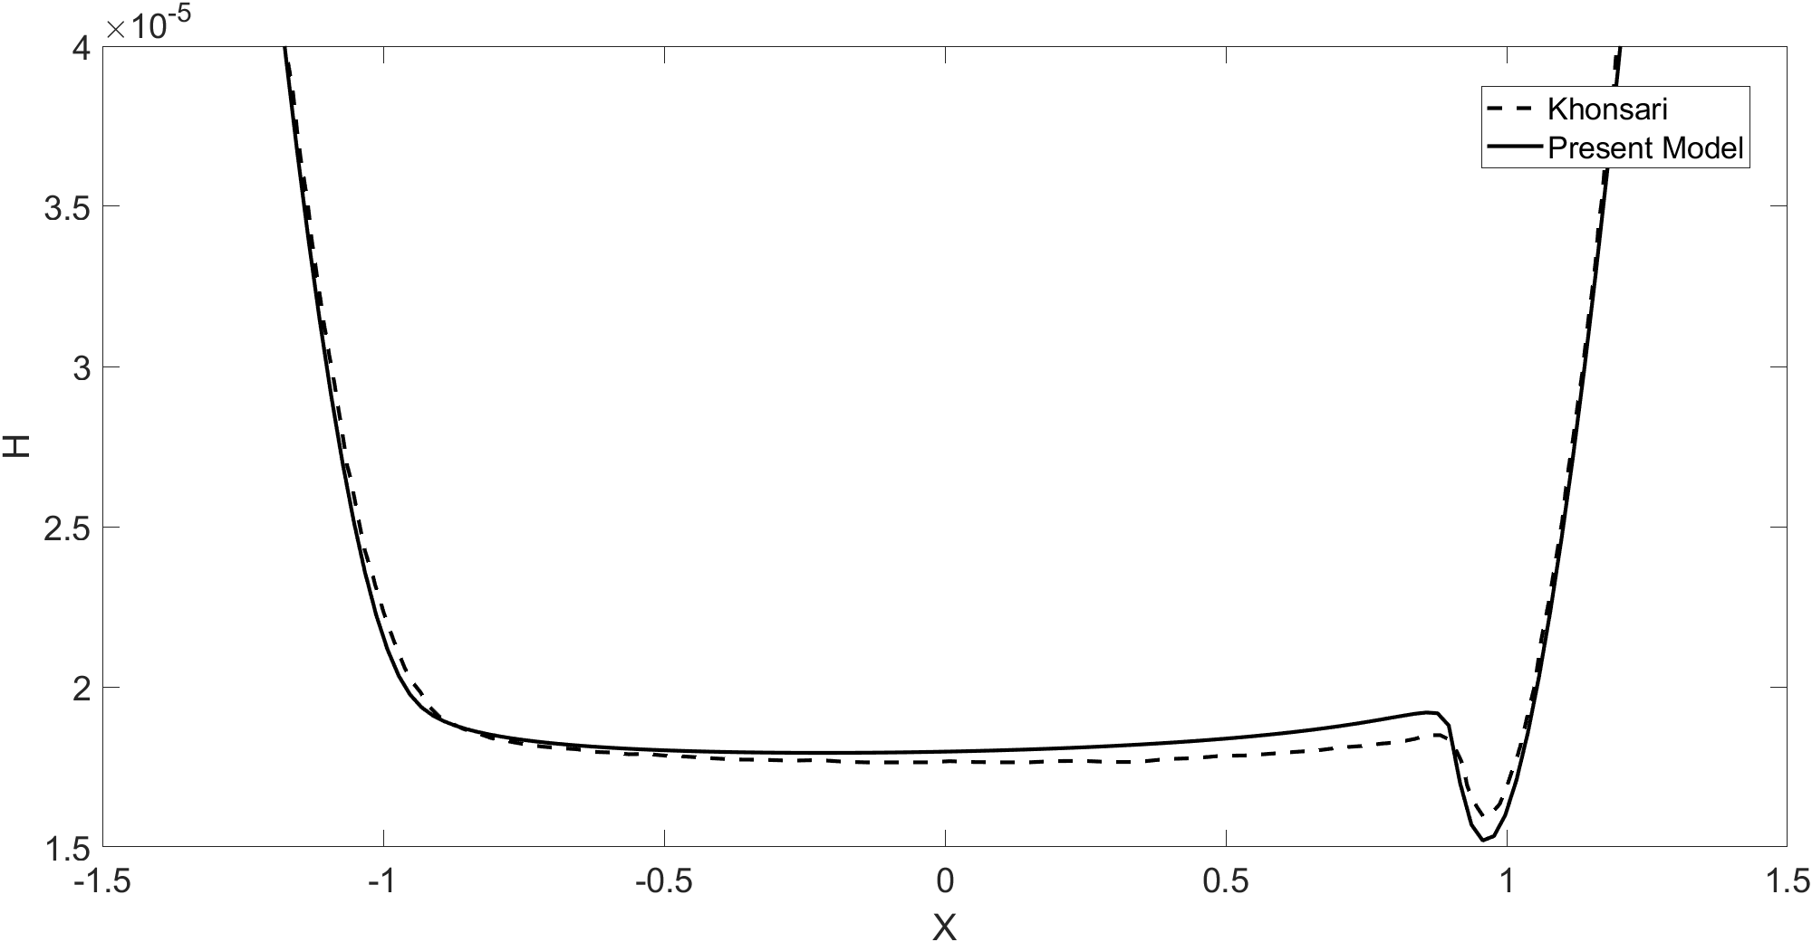

Figure - Validation of film thickness distribution, present model (solid), Masjedi and Khonsari (dash)

# Dynamic Bearing Models

To model the behaviour of rolling element bearings under conditions in electrified powertrains, component level models are required. At the core of these models is the dynamic bearing model.

Prior to the 1960’s, bearing studies were primarily conducted experimentally. Empirical formulations were derived to model their performance in early work by Stribeck [39] and Lundberg and Palmgren [49] [50] amongst others. As computer technology improved post-1960, modelling theory and application grew rapidly, pioneered largely by the work of Jones [51] and Harris [52]. In the quest for highly efficient and reliable bearings, modelling and the need for accurate representation of the physical phenomena has become important. It is not possible to conduct experimental testing for the large array of design and operational parameters that bearings are required for, therefore experimentally validated numerical analysis is employed.

## Quasi-Static Bearing Models

Early models predicting load distribution in the rolling elements can calculate bearing stiffness and fatigue life with relative accuracy. These were primarily quasi-static and based on force equilibrium. Studies of static ball bearings under simple radial loading were performed by Stribeck [39] and improved upon by Palmgren [50] for the case of nominal internal clearance. Static models computing radial and axial loads based on a load distribution factor and the angular position of the roller were found using Sjovall’s integration model [53], however this was only applicable if the ratio of radial to axial loads is within a particular range. Rumbarger [54] developed a model using Sjovall’s integral method for purely axial loading of thrust bearings, capable of calculating moment load due to axial load eccentricity.

It was the work of Jones [51] and his general theory for load deflection analysis of bearings that extended the capability of these models. His work accounted for centrifugal and gyroscopic loading, and unlike previous models, the inner bearing race had 5 degrees of freedom (DOFs); three translational and two rotational displacements that corresponds to the external forces in all three cartesian coordinates and moments applied about two – shown in Figure 9. Bearing equilibrium is obtained at each rolling element by observing the load and corresponding motion of the elements. Jones also included the individual stiffness at the contact between rolling elements and raceways, using the Hertzian contact load-deflection relationship to obtain roller load based on contact deflection. This technique could be applied to both ball and roller bearings by varying the exponent of localised deflection. This model was limited due to the assumption that misalignment effects on the elements are negligible.

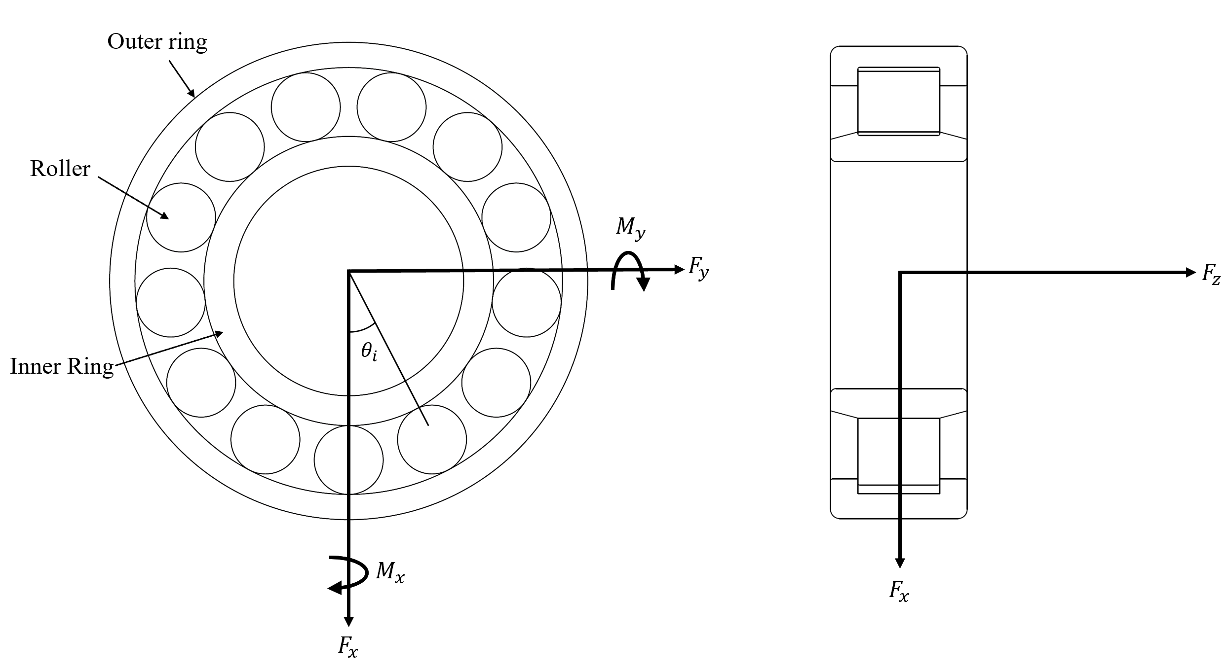

Figure - 5 DOF roller bearing model

Harris [52] improved on Jones’ model by introducing the slicing method along the length of the rollers in a roller bearing which was able to determine the load distribution along the contact. This method, known as the Jones-Harris method, was then applicable for highly loaded conditions and able to compute misaligned cases. Vector and matrix methods to analytically solves the quasi-static problem based on the work of Jones and Harris were then presented for tapered roller bearing cases by Andreason [55] and Liu [56]. de Mul et al. [57] developed a model for ball and roller bearing equilibrium and stiffness matrix calculations which has the advantage of having load-deflection equations in matrix form, therefore implementation of this model is simpler.

Additional functionality has been added to these models such as the effects of thermal expansion on the load-deflection analysis [58]. Numerical models for heat generation based on frictional torque and 3-dimensional transfer through contacting elements was used to account for the expansion. It was found that expansion increased the bearing stiffness and thus natural frequency of the shaft-spindle system due to greater interference of the roller race contact. The authors also investigated the effect of ring expansion due to centrifugal force at high speeds [59] and found that natural frequency of the spindle decreased at higher rotational speeds – of particular note for high speed automotive applications.

## Contact Load and Deflection Calculation

The contact between rolling elements and raceways and the subsequent load and deformation generated at this contact is regarded as one of the most important issued in rolling-element bearing modelling. For a ball bearing, classical Hertzian theory is used to calculate the load-deformation relationship, however the line contact is slightly more complex.

There exist three methods to determine this relationship for the line contact in roller bearings: the slicing technique, 3D contact method and the alternative slicing technique. The slicing technique [55] divides the roller-race contact region into a finite number of slices, with the total contact forces calculated from the summation of forces of each individual slice. Various formulae have been developed to perform this calculation, all yielding very similar results. A drawback of this method is that the load on each slice does not influence the surrounding slices as they are treated independently. This means that pressure concentrations such as edge stresses on the contact are not captured. The 3D contact method uses the Boussinesq half-space force-displacement relationships and flexibility method of structural analysis. The contact pressure distribution and normal approach between the bodies is found using an iterative scheme, making this a time-consuming method. Kabus et al. [60] addressed this in their 6-dof quasi-static time-domain bearing model by pre-processing a series of contacts at different centreline approaches and roller tilt angles, then interpolated these results in the actual simulations. This negated the need to solve the iterative scheme at each time step. This allowed for bearing misalignment, roller centrifugal forces, flange contact and roller tilt moments to be analysed.

Teutsch and Sauer [61] improved on the slicing technique with their alternative slicing method. Using a matrix of weighted influence coefficients, the effects of force on the deflection of neighbouring slices was captured. It is not too dissimilar in concept to the 3D contact method but with improved computation times. de Mul et al. [57] compared the slicing technique with their more complex non-Hertzian model and concluded that the simplicity and accuracy of the slicing method yielded accurate and faster results. Harris and Kotzalas [62] also concluded that the slicing technique, whilst unable to reflect edge stress concentrations, provides a fairly accurate load-displacement result as stresses are only distributed over a small area. For the purpose of load equilibrium these stresses can be neglected. Misalignment or loading on roller ends is not captured using this technique, therefore for fatigue life estimates this may produce non-conservative results; for this the approach by Kabus et al. should be used. In general, the slicing technique is the most widely used, owing to its simplicity, speed and sufficient accuracy.

## Dynamic Bearing Models

Quasi-static bearing models that solve force equilibrium within the bearing are only applicable under steady state operating conditions. Transient operating conditions such as acceleration or deceleration of the bearing requires dynamic modelling, particularly important for high-speed applications. In dynamic bearing models, a system of differential equations based on Newton’s second law of motion are used. This allows for a time-varying input force such as eccentric rotor unbalances or fluctuating loading conditions present in transmissions. Static equilibrium solutions such as those presented are used within these models to calculate load-deflection and individual element loading.

Hitherto, a multitude of models predicting bearing dynamics have been posed for roller bearings. These investigate the dynamic effect of geometrical and topographical parameters such as surface waviness, surface defects, and the variable compliance affect. This variable compliance effect is caused by time-varying stiffness variations off the inner and outer race bearing contact as rollers change their orbital position and pass through the loaded region. Even with perfect bearing geometry free from any defects, vibration will still occur due to this [63].

Simplified 2 degree of freedom models [64] consider purely in-plane motion of rolling elements in the radial and lateral directions of the bearings for investigation of frequency response to defects [65] and the varying compliance effect [66]. Time varying forces on cutting tool spindles and the effects on radial loading assuming no axial thrust loads or vibration can also be investigated in 2 DOF [67]. These models increase in complexity up to 5-DOF to observe moment loading and centrifugal effects [68] [69]. Most of these models assume the bearing rollers and races are rigid bodies. All these analyses also assume a dry contact between rolling elements and races which was assumed valid under the elastohydrodynamic regime of lubrication. The fluid film behaves as an amorphous, incompressible solid and generated pressures conform closely to a Hertzian distribution in the loaded region. This, however, neglects the effect of the lubricant film thickness in the contact mechanics and thus underestimates the contact deflection and hence load. Furthermore, the assumption of rigid rollers and races which is widely used amongst bearing dynamic models to simplify the computation is often not representative of the physical phenomena of modern shaft-bearing systems.

## Flexible Races

Most dynamic bearing models neglect global deformation of the rollers and races. Race flexibility significantly changes the ball pass harmonics and inner ring trajectory [70], which is of particular importance when considering the loading conditions in modern EV’s.

Under high speed conditions of modern EVs, centrifugal forces and external loads have a great effect on the roller and race deformation. As a weight saving measure in performance transmissions, lightweight, composite bearing housings are used which permit distortion of the outer ring under the application of gear tooth load [71]. The assumption of rigid bearing races [72] [73] in infinitely stiff housings is no longer valid and bearing behaviour is no longer independent of the housing and ring stiffness. Compliance and structural deformations of roller bearings therefore contribute to the overall dynamic performance of rotating machinery; affecting NVH, friction and wear [74] and must be inclusive in high-speed dynamic models.

Flexible raceway models studying the influences of structure deformations on load distribution and contact pressure in CRBs have been presented. These include analytical methods [75], finite element models [76] and numerical and experimental work [77] [78]. Wagner et al. [79] considered an elastic outer ring to characterize rotor dynamic parameters such as stiffness and deflection; considering centrifugal forces and gyroscopic effects in the context of high-speed turbomachinery. It is found that rotational speed has a larger influence on inner race displacement for flexible modelling compared to rigid modelling. The model contains some simplifications, including the absence of lubrication. Liu et al. [80] developed an analytical dynamic model to perform vibration analysis on a flexible and lubricated CRB system. Structural deformations of the rollers and races due to centrifugal forces and radial loads were formulated, allowing for the non-linear Hertzian contact force, lubricant stiffness and lubricant central film thickness to be found. It was found that the RMS values of acceleration for CRBs modelled with rigid raceways was significantly larger (up to 10 times at 4,000rpm) than the flexible roller cases. Furthermore, a non-uniform period of impulses relating to the changes of roller number in the loaded zone is observed due to the flexibility of components and the changes in radii and contact position between rollers and races. This behaviour is not exhibited in rigid models [81]. In this investigation, inner race speed was limited to 6,000rpm, significantly lower than the operating conditions of moderns EVs. This work also did not fully calculate the film thickness distribution, only the effect of film thickness on the lubricated contact stiffness using an analytical approach.

To understand the effects of bearing compliance on film formation, Mian et al. studied the effect of crankpin flexibility under hydrodynamic pressure [82]. Results showed that centre line film thickness due to the deformation of the crank pin was greater, resulting in a reduced peak oil film pressure. This was due to the much larger contact area as a result of the compliant structure which again could not previously be described in conventional rigid body approaches. This demonstrated the influence of flexibility on the fluid-film formation at an EHL contact. Whilst not performed on rolling element bearings, the common findings between this EHL analysis and the purely dynamic flexible body analysis suggests centrifugal force and radial loading will have a marked effect upon the conditions in the EHL contact and cannot be ignored for high-speed applications.

## Lubricated Dynamic Bearing Models

To fully numerically analyse a complement of rolling elements at each step of dynamic analysis, accounting for lubricant film thickness at the contact, is a time-consuming limitation. Historically the analysis of rolling element bearings has been decoupled into two stages. The first stage is a classic dry Hertzian-contact analysis of the roller-raceway contact due to the cyclic variation in geometric bearing centre [83]. The displacement of the bearing centre is obtained through solving equations of motion and roller load is obtained using the Hertzian load-deflection relationship. Extrapolated film thickness equations use the transient load yielded from dry analysis in a second stage study to find central film thickness. This approach does not implicitly consider the effect of the lubricant film on the prevailing bearing motion and load, which is hence underestimated. To overcome these shortcomings, quasi-static analyses employing film thickness formulae in conjunction with Hertzian contact mechanics are required.

Rahnejat and Gohar [84] employed these formulae to account for film thickness on the load share of an individual roller within the bearing complement. This coupled a two-dimensional dynamic model for a radial deep groove ball bearing with extrapolated film formulae implicitly. More reasonable bearing vibration amplitudes resulted than de-coupled analyses which were only suitable for spectral contributions and unable to produce accurate magnitudes. This work was later extended to a 5-dof model by Aini et al. [83] which included axial thrust effects and moment loading in a shaft-bearing system. The analytical film thickness formulae used [17] do not offer the capabilities of a full numerical solution such as the modelling of inlet starvation at high speeds. They do, however, offer a much faster solution when implicitly coupled with dynamic bearing analysis.

Film shape and the elastohydrodynamic pressure profile at the contact could not be calculated in these studies, preventing more detailed analysis such as thermal and sub-surface stress analysis. To determine tribological contact conditions, Mohammadpour et al. [31] utilised a full numerical elastohydrodynamic analysis explicitly. Load values on an individual roller at each instantaneous position of the orbit were obtained from the implicit tribodynamic analysis and used within the numerical model. The stiffness and damping of the EHL film is neglected due to its rigid-like stiffness which is several orders of magnitude higher that the Hertzian contact [85] [86].

These lubricated dynamic models were performed for low shaft rotational speed. In Mohammadpour’s analysis, input shaft speeds of 209 rad/s resulted in much slower entrainment velocities than in EV case studies. The rollers and races were also considered rigid in these investigations. Thus far, tribo-dynamic models have not been found that model the bearing races as flexible bodies or at high speeds.

# Bibliography

[1] X. Mosquet, H. Zablit, A. Dinger, G. Xu, M. Andersen, and K. Tominaga, ‘The Electric Car Tipping Point’, 2018.

[2] J. A. Wensing, ‘On the dynamics of ball bearings’, *Wear*, Mar. 1972.

[3] R. Gohar, *Elastohydrodynamics*. London: Imperial College Press, 1988.

[4] R. Gohar and H. Rahnejat, *Fundamentals of Tribology*, 3rd ed. London: World Scientific Publishing Europe Ltd., 2019.

[5] K. L. Johnson, *Contact Mechanics*. Cambridge: Cambridge University Press, 1985.

[6] H. Hertz, ‘On the Contact of Elastic Solids’, *J. Reine Angew, Math.*, vol. 92, pp. 156–171, 1881.

[7] O. Reynolds, ‘On the Theory of Lubrication and Its Application to Mr. Lowe’s Experiments’, *Philos. Trans. R. Soc. London*, vol. 177, pp. 157–234, 1886.

[8] H. M. Martin, ‘Lubrication of Gear Teeth’, *Engineeering (London)*, vol. 102, pp. 119–121, 1916.

[9] W. Peppler, ‘Untersuchung über die Druckübertragung bei Belasteten und Geschmierten Umlaufenden Achsparallelen Zylindern’, *Maschinenelemente-Tagung*, vol. 42, 1936.

[10] A. Meldahl, ‘Contribution to Theory of Lubrication of Gears and of Stressing of Lubricated Flanks of Gear Teeth’, *Brown Boveri Rev.*, vol. 28, no. 11, pp. 374–382, 1941.

[11] E. K. Gatcombe, ‘Lubrication Characteristics of Involute Spur Gears— A Theoretical Investigation’, *Trans. ASME*, vol. 67, pp. 177–185, 1945.

[12] A. N. Grubin, *Fundamentals of the Hydrodynamic Theory of Lubrication of Heavily Loaded Cylindrical Surfaces*, Book No. 3. Moscow (DSIR Translation): Central Scientific Research Institute for Technology and Mechanical Engineering, 1949.

[13] A. I. Petrusovich, ‘Fundamental Conclusion from the Contact-Hydrodynamic Theory of Lubrication’, *Izv. Akad. Nauk. SSSR*, vol. 2, p. 209, 1951.

[14] D. Dowson and G. R. Higginson, ‘A Numerical Solution to the Elasto-Hydrodynamic Problem’, *J. Mech. Eng. Sci.*, vol. 1, no. 1, pp. 6–15, 1959.

[15] D. Dowson and G. R. Higginson, ‘New Roller Bearing Lubrication Formula’, *Engineering*, vol. 192, pp. 158–159, 1961.

[16] D. Dowson and G. R. Higginson, *Elastohydrodynamic Lubrication*. Oxford: Pergamon, 1966.

[17] D. Dowson and S. Toyoda, ‘A Central Film Thickness Formula for Elastohydrodynamic Line’, *Proc. Fifth Leeds-Lyon Symp. Tribol. Mech. Eng. Publ.*, pp. 60–65, 1979.

[18] A. M. Ertel, ‘Hydrodynamic lubrication based on new principles’, *Akad. Nauk SSSR Prikadnaya Math. i Mekhanika*, vol. 3, no. 2, pp. 41–52, 1939.

[19] H. P. Evans and R. W. Snidle, ‘Elastohydrodynamic Lubrication of Point Contacts At Heavy Loads.’, *Proc. R. Soc. London, Ser. A Math. Phys. Sci.*, vol. 382, no. 1782, pp. 183–199, 1982.

[20] B. J. Hamrock and B. O. Jacobson, ‘Elastohydrodynamic lubrication of line contacts’, *ASLE Trans.*, vol. 27, no. 4, pp. 275–287, 1984.

[21] B. J. Hamrock and D. Dowson, ‘Isothermal Elastohydrodynamic Lubrication of Point Contacts - 1. Theoretical Formulation.’, *J Lubr Technol Trans ASME*, vol. 98 Ser F, no. 2, pp. 223–229, 1976.

[22] R. J. Chittenden, D. Dowson, J. F. Dunn, and C. M. Taylor, ‘Theoretical Analysis of the Isothermal Elastohydrodynamic Lubrication of Concentrated Contacts. I. Direction of Lubricant Entrainment Coincident With the Major Axis of the Hertzian Contact Ellipse.’, *Proc. R. Soc. London, Ser. A Math. Phys. Sci.*, vol. 397, no. 1813, pp. 245–269, 1985.

[23] H. Okumara, ‘A Contribution to the Numerical Analysis of Isothermal Elastohydrodynamic Lubrication’, *Proc. 10th Leeds-Lyon Symp. Tribol.*, 1982.

[24] L. G. Houpert and B. J. Hamrock, ‘Fast approach for calculating film thicknesses and pressures in elastohydrodynamically lubricated contacts at high loads.’, *J. Tribol.*, vol. 108, no. 3, pp. 411–419, 1986.

[25] A. A. Lubrecht, W. E. Ten Napel, and R. Bosma, ‘Multigrid, an alternative method for calculating film thickness and pressure profiles in elastohydrodynamically lubricated line contacts’, *J. Tribol.*, vol. 108, no. 4, pp. 551–556, 1986.

[26] C. H. Venner, W. E. ten Napel, and R. Bosma, ‘Advanced Multilevel Solution of the EHL Line Contact Problem’, *J. Tribol.*, vol. 112, no. 3, pp. 426–431, Jul. 1990.

[27] F. Chevalier, A. A. Lubrecht, P. M. E. Cann, F. Colin, and G. Dalmaz, ‘Starvation Phenomena in EHL Point Contacts: Influence of Inlet Flow Distribution’, *Proc. 22nd Leeds-Lyon Symp. Tribol. Elseviers Tribol. Ser.*, vol. 31, pp. 213–233, 1995.

[28] P. M. Lugt and G. E. Morales-Espejel, ‘A review of elasto-hydrodynamic lubrication theory’, *Tribol. Trans.*, vol. 54, no. 3, pp. 470–496, 2011.

[29] P. E. Wolveridge, K. P. Baglin, and J. F. Archard, ‘The Starved Lubrication of Cylinders in Line Contact’, *Proc. Inst. Mech. Eng.*, vol. 185, no. 1, pp. 1159–1169, Jun. 1970.

[30] B. J. Hamrock and D. Dowson, ‘Isothermal Elastohydrodynamic Lubrication of Point Contacts - 4. Starvation Results.’, *Am. Soc. Mech. Eng.*, no. 76-Lub-31, pp. 223–228, 1976.

[31] M. Mohammadpour, P. Johns-Rahnejat, and H. Rahnejat, ‘Roller bearing dynamics under transient thermal-mixed non-Newtonian elastohydrodynamic regime of lubrication’, *Proc. Inst. Mech. Eng. Part K J. Multi-body Dyn.*, vol. 229, no. 4, pp. 407–423, Dec. 2015.

[32] P. Yang, S. Qu, Q. Chang, and F. Guo, ‘On the theory of thermal elastohydrodynamic lubrication at high slide-roll ratios - Line contact solution’, *J. Tribol.*, vol. 123, no. 1, pp. 36–41, 2001.

[33] K. H. Kim and F. Sadeghi, ‘Three-Dimensional Temperature Distribution in EHD Lubrication: Part I—Circular Contact’, *J. Tribol.*, vol. 114, no. 1, pp. 32–41, Jan. 1992.

[34] K. H. Kim and F. Sadeghi, ‘Three-dimensional temperature distribution in ehd lubrication: Part II-Point contact and numerical formulation’, *J. Tribol.*, vol. 115, no. 1, pp. 36–45, 1993.

[35] X. Liu and P. Yang, ‘Analysis of the thermal elastohydrodynamic lubrication of a finite line contact’, *Tribol. Int.*, 2002.

[36] D. Zhu and S. Wen, ‘A Full Numerical Solution for the Thermoelastohydrodynamic Problem in Elliptical Contacts’, *J. Tribol.*, vol. 106, no. 2, pp. 246–254, Apr. 1984.

[37] W. Habchi, D. Eyheramendy, S. Bair, P. Vergne, and G. Morales-Espejel, ‘Thermal elastohydrodynamic lubrication of point contacts using a Newtonian/generalized Newtonian lubricant’, *Tribol. Lett.*, vol. 30, no. 1, pp. 41–52, 2008.

[38] H. S. Cheng, ‘Isothermal Elastohydrodynamic Theory for the Full Range of Pressure-Viscosity Coefficient’, *J. Lubr. Technol.*, vol. 94, no. 1, pp. 35–43, Jan. 1972.

[39] R. Stribeck, ‘Ball Bearings for Various Loads’, *Trans. ASME*, vol. 29, pp. 420–463, 1907.

[40] Y. H. Ali, R. Abd Rahman, and R. I. R. Hamzah, ‘Artificial neural network model for monitoring oil film regime in spur gear based on acoustic emission data’, *Shock Vib.*, vol. 2015, 2015.

[41] R. Larsson, ‘EHL Film Thickness Behavior’, in *Encyclopedia of Tribology*, Boston, MA: Springer US, 2013, pp. 817–827.

[42] K. A. Hoffmann and S. T. Chiang, *Computational Fluid Dynamics*, Fourth. Wichita: Engineering Education System, 2000.

[43] C. Barus, ‘Isothermals isopietics and isometrics in relationship to viscosity’, *Am. J. Sci. 3rd Ser.*, vol. 45, pp. 87–96, 1893.

[44] C. Roelands, ‘Correlational aspects of the viscosity-temperaturepressure relationship of lubricating oils".’, Delft University. Delft, 1966.

[45] L. Houpert, ‘New results of traction force calculations in elastohydrodynamic contacts.’, vol. 107, no. April, pp. 241–245, 1984.

[46] D. Dowson and G. R. Higginson, *Elasto-hydrodynamic lubrication*, SI. Oxford: Pergamon Press, 1977.

[47] R. F. Crouch and A. Cameron, ‘Viscosity-temperature equations for lubricants’, *J. Inst. Pet.*, vol. 47, pp. 307–313, 1961.

[48] M. M. Khonsari, ‘Film Thickness and Asperity Load Formulas for Line-Contact Elastohydrodynamic Lubrication With Provision for Surface Roughness’, vol. 134, no. January, 2012.

[49] G. Lundberg and A. Palmgren, ‘Dynamic Capacity of Roller Bearings’, *Acta Polytech. Mech. Eng. Ser. R. Swedish Acad. Eng. Sci.*, vol. 2, no. 4, pp. 96–127, 1952.

[50] A. Palmgren, ‘Ball and Roller Bearing Engineering’, Philadelphia, 1959.

[51] A. B. Jones, ‘A general theory for elastically constrained ball and radial roller bearings under arbitrary load and speed conditions’, *J. Fluids Eng. Trans. ASME*, vol. 82, no. 2, pp. 309–320, 1960.

[52] T. A. Harris, *Roller Bearing Analysis*, 3rd ed. New York: John Wiley and Sons, 1984.

[53] H. Sjovall, ‘The Load Distribution within Ball and Roller Bearings under Given External Radial and Axial Load’, *Tek. Tidskr. Mek.*, vol. 9, 1933.

[54] J Rumbarger, ‘Thurst bearings with eccentric loads’, *Mach des.*, pp. 172–179, 1962.

[55] S. Andreason, ‘Load distribution in a taper roller bearing arrangement considering misalignment’, no. June, pp. 84–92, 1973.

[56] J. Y. Liu, ‘Analysis of Tapered Roller Bearings Considering High Speed and Combined Loading.’, *Am. Soc. Mech. Eng.*, no. 76-LubS-9, pp. 564–572, 1976.

[57] J. M. de Mull, J. M. Vree, and D. A. Maas, ‘Equilibrium and associated load distribution in ball and roller bearings loaded in five degrees of freedom while neglecting friction - part I: application to roller bearings and experimental verification.’, vol. 111, no. January, 1988.

[58] B. R. Jorgensen and Y. C. Shin, ‘Dynamics of machine tool spindle/bearing systems under thermal growth’, *J. Tribol.*, vol. 119, no. 4, pp. 875–882, 1997.

[59] B. R. Jorgensen and Y. C. Shin, ‘Dynamics of spindle-bearing systems at high speeds including cutting load effects’, *J. Manuf. Sci. Eng. Trans. ASME*, vol. 120, no. 2, pp. 387–394, 1998.

[60] S. Kabus, M. R. Hansen, and O. Mouritsen, ‘A new quasi-static cylindrical roller bearing model to accurately consider non-hertzian contact pressure in time domain simulations’, *J. Tribol.*, vol. 134, no. 4, pp. 1–10, 2012.

[61] R. Teutsch and B. Sauer, ‘An alternative slicing technique to consider pressure concentrations in non-Hertzian line contacts’, *J. Tribol.*, vol. 126, no. 3, pp. 436–442, 2004.

[62] T. A. Harris and M. N. Kotzales, *Advanced Concepts of Bearing Technology*, Fifth. Boca Raton, FL: Taylor and Francis Group, 2007.

[63] J. Sopanen and A. Mikkola, ‘Dynamic model of a deep-groove ball bearing including localized and distributed defects. Part’, *Proc. Inst. Mech. Eng. Part K J. Multi-body Dyn.*, vol. 217, no. 3, pp. 201–211, 2003.

[64] C. T. Walters, ‘The dynamics of ball bearings’, *J. Tribol.*, vol. 93, no. 1, pp. 1–10, 1971.

[65] L. D. Meyer, F. F. Ahlgren, and B. Weichbrodt, ‘An Analytic Model for Ball Bearing Vibrations to Predict Vibration Response to Distributed Defects’, *J. Mech. Des.*, vol. 102, no. 2, pp. 205–210, Apr. 1980.

[66] C. S. Sunnersjö, ‘Varying compliance vibrations of rolling bearings’, *J. Sound Vib.*, vol. 58, no. 3, pp. 363–373, 1978.

[67] M. Matsubara, H. Rahnejat, and R. Gohar, ‘Computational modelling of precision spindles supported by ball bearings’, *Int. J. Mach. Tools Manuf.*, vol. 28, no. 4, pp. 429–442, 1988.

[68] H. Rahnejat and S. Rothberg, *Mulit-body dynamics: Monitoring and simulation techniques III*, First. New York: Wiley, 2004.

[69] P. K. Gupta, ‘Dynamics of Rolling-Element Bearings—Part I: Cylindrical Roller Bearing Analysis’, *J. Lubr. Technol.*, vol. 101, no. 3, pp. 293–302, Jul. 1979.

[70] A. Leblanc, D. Nelias, and C. Defaye, ‘Nonlinear dynamic analysis of cylindrical roller bearing with flexible rings’, vol. 325, pp. 145–160, 2009.

[71] A. B. Jones and T. A. Harris, ‘Analysis of a rolling-element idler gear bearing having a deformable outer-race structure’, *J. Fluids Eng. Trans. ASME*, vol. 85, no. 2, pp. 273–278, 1963.

[72] F. Wang, M. Jing, J. Yi, G. Dong, H. Liu, and B. Ji, ‘Dynamic modelling for vibration analysis of a cylindrical roller bearing due to localized defects on raceways’, *Proc. Inst. Mech. Eng. Part K J. Multi-body Dyn.*, vol. 229, no. 1, pp. 39–64, 2015.

[73] J. Liu, Z. Shi, and Y. Shao, ‘An analytical model to predict vibrations of a cylindrical roller bearing with a localized surface defect’, *Nonlinear Dyn.*, vol. 89, no. 3, pp. 2085–2102, 2017.

[74] N. Lynagh, H. Rahnejat, M. Ebrahimi, and R. Aini, ‘Bearing induced vibration in precision high speed routing spindles’, *Int. J. Mach. Tools Manuf.*, vol. 40, no. 4, pp. 561–577, 2000.

[75] G. Cavallaro, D. Nelias, and F. Bon, ‘Analysis of high-speed intershaft cylindrical roller bearing with flexible rings’, *Tribol. Trans.*, vol. 48, no. 2, pp. 154–164, 2005.

[76] N. Demirhan and B. Kanber, ‘Stress and displacement distributions on cylindrical roller bearing rings using FEM’, *Mech. Based Des. Struct. Mach.*, vol. 36, no. 1, pp. 86–102, 2008.

[77] S. Lacroix, D. Nélias, and A. Leblanc, ‘Four-point contact ball bearing model with deformable rings’, *J. Tribol.*, vol. 135, no. 3, pp. 1–8, 2013.

[78] S. Lacroix, D. Nélias, and A. Leblanc, ‘Experimental Study of Four-Point Contact Ball Bearing with Deformable Rings’, *Tribol. Trans.*, vol. 58, no. 6, pp. 963–970, Nov. 2015.

[79] C. Wagner, A. Krinner, T. Thümmel, and D. Rixen, ‘Full dynamic ball bearing model with elastic outer ring for high speed applications’, *Lubricants*, vol. 5, no. 2, 2017.

[80] J. Liu, C. Tang, and Y. Shao, ‘An innovative dynamic model for vibration analysis of a flexible roller bearing’, *Mech. Mach. Theory*, vol. 135, pp. 27–39, 2019.

[81] J. Liu, ‘An Analytical Dynamic Model of a Hollow Cylindrical Roller Bearing’, vol. 140, no. November, pp. 1–14, 2018.

[82] O. Mian, D. Merritt, and D. Wang, ‘The Effect of crankshaft flexibility on the EHL of connecting rod bearings’, *SAE Tech. Pap.*, no. 724, 2002.

[83] R. Aini, H. Rahnejat, and R. Gohar, ‘A five degrees of freedom analysis of vibrations in precision spindles’, *Int. J. Mach. Tools Manuf.*, vol. 30, no. 1, pp. 1–18, 1990.

[84] H. Rahnejat and R. Gohar, ‘The Vibrations of Radial ball bearings’, *Proc. Inst. Mech. Eng. Part C J. Mech. Eng. Sci.*, vol. 199, no. 3, pp. 181–193, 1985.

[85] D. W. Dareing and K. L. Johnson, ‘Fluid Film Damping of Rolling Contact Vibrations’, *J. Mech. Eng. Sci.*, vol. 17, no. 4, pp. 214–218, Aug. 1975.

[86] H. Mehdigoli, H. Rahnejat, and R. Gohar, ‘Vibration response of wavy surfaced disc in elastohydrodynamic rolling contact’, *Wear*, vol. 139, no. 1, pp. 1–15, 1990.

[87] R. Takeda, G. Lisco, T. Fujisawa, L. Gastaldi, H. Tohyama, and S. Tadano, ‘Drift Removal for Improving the Accuracy of Gait Parameters Using Wearable Sensor Systems’, *Sensors*, vol. 14, no. 12, pp. 23230–23247, Dec. 2014.

[88] B. J. Hamrock and D. Dowson, *Ball Bearing Lubrication: The Elastohydrodynamics of Elliptical Contacts*. New York: John Wiley * Sons, 1981.